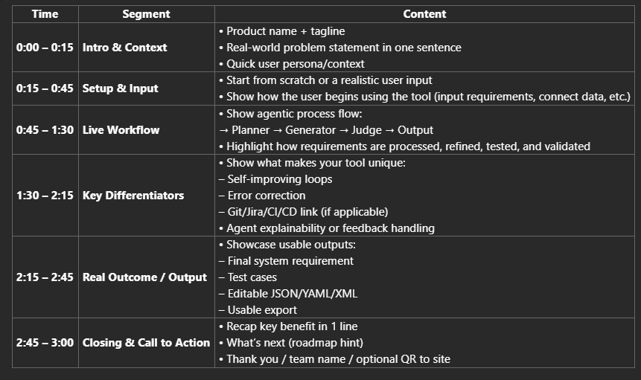

**Greetings Everyone!**

**Introducing WHALE — Stands for “We Have to Look into Everything”**

WHALE is an AI-powered systems engineering co-pilot for the Automotive Industry that transforms messy customer inputs into test-ready requirements, which is 60% faster.

It reduces team size by over 70%, boosts IREB/ASPICE compliance, and eliminates reviewer fatigue.

It's a Smarter, faster, future-ready solution— that's WHALE.

“Let’s see WHALE in action.”

Step 1: Sys.1 Elicitation  
“We start by feeding WHALE raw customer inputs — like emails, tickets, and slides. These are typically messy and unstructured.”

*Step 2: SYS.2 Analysis*  
“Using Hugging Face models fine-tuned on systems engineering patterns, WHALE extracts, clusters, and drafts high-quality system requirements — automatically.”

*Step 3: SYS.2 Review*  
“Next, our Judge Agent — powered by Cursor AI — checks each requirement for compliance with standards like IREB and ASPICE.”

*Step 4: SYS.5 Test Case Generation*  
“Finally, WHALE links requirements to autogenerated test cases, completing the full cycle in just minutes instead of months.”

“So that’s WHALE — reducing 3 months of manual work to 3 weeks, with 70% fewer engineers. It’s smart, adaptive, and built for the future of systems engineering.”

**ROAD Map**

*“WHALE” is designed to be both high-impact and commercially scalable across regulated industries.*

* **2025 Q2–Q3**: Pilot programs with OEMs using 10-seat license
* **2025 Q4–2026 Q2**: VPC + On-prem deployments for SDV programs
* **2026+**: Expansion to Aerospace, Medical Devices, Defence (ISO 26262/IEC 62304/DO-178 readiness)
* **Team**:
  + Mr. Mohinder Pandey – Product & Strategy Expert
  + Myself: Ranjit Jagtap – AI/ML Engineer
  + Mr. Chaitanya Kulkarni – Infra & DevOps Engineer
  + Mr. Deepak Garg – Leading collaborations to integrate WHALE with industry leaders

**✅ Slide 1: From Chaos to Clarity – Why Requirements Engineering is Broken**

*Modern engineering programs break down not because of innovation—but due to outdated manual workflows at their foundation.*

* **Customer inputs (emails, presentations, tickets) take 3–4 months to convert into test-ready system requirements**
* **No automated checks for industry standards like IREB or ASPICE**
* **Inconsistent quality due to scattered toolchains and reviewer fatigue**
* **No feedback loop to retain or learn from engineering edits**
* Git, Jira, and ALM tools are disconnected from requirement workflows
* Engineering delays cascade into cost overruns, rework, and team churn

**✅ Slide 2: What Our Early Data Shows – Real-World Metrics**

*Our pilot programs show a decisive shift in engineering velocity and quality.*

* **70% reduction in engineering headcount (20 → 6) in initial pilots**
* **Requirement-to-testcase cycle cut from 3 months to 3 weeks (60%+ faster)**
* **IREB compliance improved from 62% → 85% via Judge Agent**
* 400+ user edits captured and used for learning; 45% better judged outputs
* 15+ demo requests from OEM program managers within first 3 weeks
* Deployed with GitHub Codespaces and Hugging Face APIs

**✅ Slide 3: How the Agents Work – Multi-Agent Technical Pipeline**

*AgentX uses four intelligent agents, each with a specific role. Together, they deliver an editable, explainable automation loop.*

* **Planner**: Extracts structure and breaks down customer inputs
* **Generator**: Converts inputs to Sys.1 → Sys.5 and test cases
* **Judge**: Applies IREB/UAT scoring, halts poor outputs
* **Memory**: Learns from user edits and improves future generations
* Powered by RAG-based vector memory, prompt chaining, and dynamic thresholds
* Fully traceable via Git/Jira integrations and ALM export formats
* System-level and test-level outputs are editable, version-controlled, and standards-aware

**✅ Slide 4: From Pilots to Profit – Business Model & Expansion Plan**

*AgentX is designed to be both high-impact and commercially scalable across regulated industries.*

* **2025 Q2–Q3**: Pilot programs with OEMs using 10-seat license
* **2025 Q4–2026 Q2**: VPC + On-prem deployments for SDV programs
* **2026+**: Expansion to Aerospace, Medical Devices, Defence (ISO 26262/IEC 62304/DO-178 readiness)
* **Revenue Streams**:
  + SaaS Seat Licensing
  + Agent API Usage (per-call pricing)
  + Bring Your Own Model (BYOM) or fine-tuning packages
* Modular architecture allows rapid adaptation across domains

**✅ Slide 5: Why Us – Proven Domain Expertise & Technical Execution**

*This isn’t a research prototype. It’s built by engineers who have delivered real SDV programs.*

* 80+ years combined experience across Automotive, Aerospace, AI/ML
* Judge Agent framework ensures explainability + auto-improvement
* All outputs audit-traceable, editable, and standards-compliant
* Led by engineering veterans from Onward Technologies, experienced in OEM engagements
* Designed from the ground up to solve SDV and system engineering bottlenecks

**✅ Slide 6: Standing Apart – Why AgentX Is Unique**

*Unlike legacy tools, AgentX is not just a wrapper on LLMs—it’s an engineered system with memory, judgment, and control.*

|  |  |  |
| --- | --- | --- |
| **Capability** | **Legacy Tools** | **AgentX Edge** |
| End-to-End Coverage | Fragmented | Full pipeline: input → output |
| Compliance Validation | Manual QA | Judge Agent with dynamic scoring |
| Edit Memory | Non-existent | RAG + vector-based continuous learning |
| Git/Jira Integration | Partial | Git-native + sprint traceability |
| Editable Outputs | Static PDF/Excel | Editable, version-controlled artifacts |
| Security & Deployment | Undefined | SOC2-ready, VPC/on-prem/air-gapped |

**✅ Slide 7: Go-To-Market Strategy – Penetrate, Prove, Expand**

*We begin with OEMs and Tier-1s who feel this pain acutely—and grow into adjacent verticals.*

* **Phase 1**: Secure 3–5 OEM/Tier-1 pilots (Q2–Q3 2025)
* **Phase 2**: Convert to paid VPC deployments + publish benchmarks
* **Phase 3**: Expand to Aerospace, MedTech, Defense with compliance alignment
* GTM:
  + Direct sales via founder network
  + Co-marketing with ALM/Tier-1 partners
  + API-first onboarding for SaaS customers

**✅ Slide 8: Who We Empower – Customer Personas**

*AgentX is used across roles—not just engineers.*

|  |  |  |
| --- | --- | --- |
| **Role** | **Challenge** | **AgentX Benefit** |
| Program Manager | Unclear planning, rework cycles | Dashboard + traceable test coverage |
| System Engineer | Time-consuming formatting, QA | Autogenerated, editable IREB-aligned drafts |
| QA Manager | Test coverage gaps at late stages | Early test case derivation + UAT feedback loop |
| Compliance Lead | Manual audit work | Inline IREB/ASPICE scoring, conformance exports |
| CIO | Black-box AI fears | Transparent, explainable, editable agents |

**✅ Slide 9: Demo Highlights – See the Agents in Action**

*From raw input to validated test cases in minutes.*

* Uploads accepted: XLS, tickets, field reports, emails
* Planner Agent breaks down by intent + structure
* Generator converts to Sys.1–Sys.5 + test cases
* Judge Agent evaluates using IREB/UAT thresholds
* Memory Agent learns from edits, enabling refinement
* **Live Demos** available via GitHub Codespaces + Hugging Face

**✅ Slide 10: Modular Architecture – Secure & Scalable**

*Built to scale across enterprises, with replaceable modules.*

* Containerized agent modules (Planner, Generator, Judge, Memory)
* RAG Store + Prompt Memory Store for semantic retrieval
* GitOps integration + CI/CD ready
* Deployable across SaaS, VPC, On-prem, Air-gapped
* Interfaced via SDKs and REST APIs
* Built-in role-based access controls

**✅ Slide 11: Engineered for Precision – Technical Insights**

* RAG Store enables context-aware generation and semantic memory
* In-memory edit tracking improves future outputs
* Role-based prompt engineering (System Eng vs Test Manager)
* Prompt chaining with halt conditions (Judge thresholds)
* Safety gates prevent hallucinations or invalid content
* Output confidence scoring + rationale explanation
* Compatible with GitOps + ALM tools

**✅ Slide 12: Performance Gains – Product Metrics**

|  |  |  |  |
| --- | --- | --- | --- |
| **Metric** | **Before (Manual)** | **After (AgentX)** | **Benefit** |
| Req-Testcase Cycle Time | 3–4 months | 3 weeks | 75% faster |
| Avg. IREB Score | 62% | 85% | +23% increase |
| Manual Review Rate | 100% | ~30% | -70% reduction |
| QA Feedback Loop | 2 weeks | 2 days | 85% faster |
| Edit Impact on Quality | — | +45% | Memory-based improvement loop |

**✅ Slide 13: Built for Trust – Security & Compliance**

* VPC, On-Prem, Air-Gapped deployment modes
* Role/workspace-level agent control
* Git + Jira logs with full traceability
* Inline scoring for IREB, ASPICE, UAT attributes
* Modular agents enable resilience + fault containment
* SOC2 + ISO 27001 readiness built-in
* GDPR & data sovereignty respected

**✅ Slide 14: Four Core Agents – Deep Dive**

|  |  |  |  |
| --- | --- | --- | --- |
| **Agent** | **Purpose** | **Key Features** | **Customizable** |
| Planner | Input structure | Intent detection, block mapping | ✅ |
| Generator | Drafts Sys.1–5 + tests | Prompt templates, fallback + reuse control | ✅ |
| Judge | Evaluate quality | IREB/UAT score, halt trigger, re-ask | ✅ |
| Memory | Learn & refine | Vector memory, edit logging, recall matching | ✅ |

* Each agent is swappable with private LLMs or Hugging Face APIs
* Fully versioned, traceable, and configurable

**✅ Slide 15: Flexible Engagement – Pricing**

|  |  |  |  |
| --- | --- | --- | --- |
| **Tier** | **Mode** | **Features** | **Price** |
| Starter | SaaS | 10 seats, capped API calls | $99K/year |
| Growth | VPC | Full compliance, secure storage | $250K–$300K |
| Enterprise | On-Prem | BYOM support, full customization | $400K–$600K |
| Custom | Air-gapped | Regulated data loop, isolated runtime | > $600K |

Optional add-ons: SOC2 kits, connector SDKs, Hugging Face fine-tuning support

**✅ Slide 16: Funding Ask – Fueling the Next Leap**

* **Ask**: $2M for a 12-month runway
* **Equity**: 20% (Seed Round @ $10M post-money)
* **Allocation**:
  + 40%: Engineering + DevOps
  + 20%: Infrastructure (LLM, VPC, APIs)
  + 15%: Licensing (toolchain, LLMs)
  + 15%: GTM + Customer Pilots
  + 10%: Travel + Investor Relations
* Vision: Build the **category-defining agentic system** for requirements engineering

**✅ Slide 17: Advisors & Partners – Who We Want at the Table**

* **Advisors**:
  + Former CTOs / Heads of Engineering (OEMs, Tier-1s)
  + ASPICE/ISO 26262 system engineering veterans
  + GenAI governance + LLM safety experts
* **Design Partners**:
  + OEMs with SDV/digital twin roadmaps
  + Tier-1s seeking engineering automation
* **Incentives**:
  + Branding visibility, roadmap influence, pilot discounts

**✅ Slide 18: We Accelerate Trust – Summary**

*AgentX Agents don’t just automate—they elevate engineering.*

* First editable, judge-aware, explainable GenAI stack
* 4x acceleration in SDV requirement-to-test workflows
* Built for compliance, security, and enterprise scale
* Transparent, safe, user-controllable—**not a black box**
* From input chaos to testable clarity—in weeks, not months

**✅ Slide 19: Appendix – Supporting Materials**

* Input → System Requirement → Test Case (Sys.1–5 flow visual)
* Prompt chaining logic + Judge threshold examples
* ASPICE + IREB attribute checklist
* Anonymized pilot metrics
* Code snippets for GitOps & CI/CD flows
* Agent benchmarking across LLMs

**✅ Slide 20: Let’s Build the Future Together – Contact & Demo**

* **Team**:
  + Mohinder Pandey – Product & Strategy
  + Ranjit Jagtap – AI/ML
  + Chaitanya Kulkarni – Infra & DevOps
  + Deepak Garg – Partnerships
* **Contact**: [mohinder@agentx.ai](mailto:mohinder@agentx.ai) | +91 79724 28399
* **Demo Access**: GitHub Codespaces | Hugging Face
* **Next Steps**:
  + Request Demo Access
  + Join Pilot Program
  + Book Investor Briefing